**TITLE OF PROJECT REPORT**

**“Sales-Analysis”**

### PROJECT REPORT

#### Submitted by

Manpreet Singh Goindi

(2210993813)

**BE-CSE (Artificial Intelligence)**

***Guided by***

**<Dr. Lavish Arora>**

**CHITKARA UNIVERSITY INSITUTE OF ENGINEERING & TECHNOLOGY**

**CHITKARA UNIVERSITY, RAJPURA**

**December-2024**

ACKNOWLEDGEMENTS

With immense please I, Mr. Manpreet Singh Goindi   
presenting “Sales-Analysis” project report as part of  
the curriculum of ‘BE-CSE (AI) ’.

I would like to express my sincere thanks to Dr. Lavish Arora, for his/her valuable guidance and support in completing my project.

I would also like to express my gratitude towards our dean Dr. Sushil Narang (dean name) for giving me this great opportunity to do a project on Data Analysis (topic name). Without their support and suggestions, this project would not have been completed.

Signature………..

Name:

Roll No:

**Abstract**

Supermarkets are an essential part of daily life, providing consumers with access to a wide variety of products. However, managing and optimizing supermarket operations and understanding customer behaviour from large datasets can be a significant challenge. This project focuses on leveraging data analytics and machine learning techniques to analyze supermarket sales data, with the ultimate goal of uncovering actionable insights that improve decision-making in areas like inventory management, pricing strategies, and customer behaviour.

The project utilizes advanced data processing and visualization techniques to examine large volumes of transactional data generated within a supermarket environment. By analyzing this data, key trends and patterns can be identified that provide valuable information for optimizing business operations and improving profitability. Specifically, the project aims to:

1. **Customer Behaviour Understanding**:
   * One of the primary goals of this project is to gain insights into customer preferences and buying patterns. By analyzing transaction data, we can identify which products are popular, which customer segments are more likely to purchase specific items, and the seasonal or time-dependent demand trends. Understanding customer behaviour helps supermarkets improve their marketing strategies, offer personalized discounts, and better serve their customers, leading to increased customer loyalty and sales.
2. **Sales Performance Analysis**:
   * Another key aspect of the project is analyzing sales performance over time. By tracking sales data across different periods, we can determine which products are performing well and which are not. This analysis helps in identifying underperforming products, adjusting inventory levels, and suggesting targeted promotions to boost sales. The sales performance analysis also helps to determine the effectiveness of past marketing campaigns and the return on investment (ROI) for different strategies.
3. **Operational Optimization**:
   * The project focuses on improving operational efficiency by predicting demand and optimizing inventory management. Accurate demand forecasting helps supermarkets avoid stockouts or overstocking, both of which can negatively impact profitability. Additionally, optimizing inventory levels reduces waste and ensures that popular products are available when needed, improving the overall customer experience. Through data analysis, the project helps in creating strategies for smarter purchasing, pricing, and stocking of products.
4. **Predictive Modeling for Demand Forecasting**:
   * Predicting future sales and demand patterns is a crucial aspect of this project. By using machine learning algorithms and time-series analysis, the project builds predictive models to forecast sales trends, product demand, and inventory needs. This helps supermarkets plan better and reduce risks associated with product shortages or surplus inventory. Predictive analytics also plays a role in pricing strategies, ensuring that products are priced dynamically according to predicted demand.
5. **Pricing Strategy and Promotions**:
   * Dynamic pricing strategies are developed based on data analysis. By understanding demand elasticity, customer behavior, and competitor pricing, supermarkets can optimize product pricing to maximize sales and profit margins. Additionally, data-driven insights into past promotional campaigns allow supermarkets to fine-tune their promotional strategies. Identifying the best times for discounts or promotions based on customer behavior and sales trends ensures that these efforts yield the best return on investment.

**Expected Outcomes**: The expected outcome of this project is to provide supermarkets with actionable insights derived from their sales and transactional data. These insights will help businesses make informed decisions related to:

* Optimizing inventory levels to ensure that popular products are stocked at the right times and reduce waste from unsold items.
* Tailoring marketing strategies to customer behavior and preferences, improving customer satisfaction and loyalty.
* Enhancing pricing strategies by predicting demand and identifying the right times for discounts or promotions.
* Increasing operational efficiency by automating demand forecasting, reducing human error, and providing data-driven recommendations.
* Improving overall profitability through better decision-making and more targeted operational strategies.

# CHAPTERS

## TOPICS PAGE NO.

* List of Figures………………………….………………………….………………………05
* Introduction ………….………………………….………………………………………..07
* Problem Formulation…………….……………………….……………………………….08
* Methodology…………….……………………….………………………………………..9
* Flowchart……………………….…………….……………………….…………………..12
* Software Requirements…………………………….……………………….……………..13
* Results…………….………………………….……………………………………………14
* Conclusion and Future Work…………….………………………….………...…………..18
* References…………….……………………….…………………………………………..20

**LIST OF FIGURES**

FIG 4.1 - Pg 12 - Flowchart explaining the systematic flow of application

FIG6.1- pg14 – Dataset with no null value

FIG 6.2 - Pg 15 – Correlation Heat-Map of columns

FIG 6.3 - Pg 16 – Relationship between gross income and tax

FIG 6.4 - Pg 16 – Histogram showing sales with respect to columns

FIG 6.5 - Pg 17 – Box-plot Graph between Rating and quantity

### Introduction

Supermarket sales analysis is a critical component of business strategy, as it helps to uncover key insights that drive operational efficiency and profitability. With the ever-growing volume of transactional data generated by supermarkets, businesses are increasingly challenged in understanding customer preferences, managing inventory effectively, and optimizing sales strategies. In today’s competitive retail environment, without proper data analysis, supermarkets are at risk of making uninformed decisions that can lead to missed opportunities and inefficiencies.

This project aims to address these challenges by analyzing supermarket sales data to provide actionable insights into customer behavior, sales performance, and inventory management. By examining transaction data, the project seeks to identify trends and patterns that can optimize operations and improve decision-making processes across various business functions.

The project focuses on three key areas:

* **Customer Behavior Analysis**: Understanding purchasing patterns and preferences to improve the customer experience. By analyzing this data, the supermarket can develop personalized promotions, recommendations, and improve overall customer satisfaction.
* **Sales Performance Insights**: Tracking revenue trends, identifying top-selling products, and understanding customer preferences. These insights enable the supermarket to tailor product offerings and marketing strategies to boost sales.
* **Operational Optimization**: Supporting inventory management, pricing strategies, and promotional planning. By understanding sales fluctuations and demand trends, the project helps ensure that products are stocked efficiently, prices are set competitively, and promotions are timed effectively.

Through the integration of technologies such as Python, Pandas, Numpy, Matplotlib, and Seaborn, this project provides a comprehensive approach to analyzing supermarket sales data. The insights gained from this analysis will enable supermarkets to make informed decisions, optimize their operations, and ultimately enhance their profitability and market competitiveness. By leveraging these data-driven techniques, the project aims to bridge the gap between data and actionable strategies that drive business growth in the modern retail landscape.

Top of Form

Bottom of Form

### 2. ****Problem Formulation****

Supermarkets generate vast amounts of transactional data, which, if analyzed effectively, can lead to significant improvements in sales strategies, inventory management, and customer satisfaction. However, without proper analysis, businesses often struggle to uncover actionable insights that can drive decision-making and operational optimization. The challenges that arise from handling large volumes of data include:

1. **Understanding Customer Preferences**: Supermarkets need to identify purchasing patterns and preferences to enhance the customer experience. However, due to the complexity and scale of transactional data, it becomes difficult to understand these preferences without advanced analytical methods. Traditional methods are often time-consuming and do not provide real-time insights into customer behavior.
2. **Sales Forecasting and Trend Analysis**: Accurate sales forecasting is crucial for maintaining optimal stock levels and avoiding overstocking or stockouts. Without effective data analysis, predicting demand trends for various products can be highly inaccurate. Additionally, tracking which products are performing well, and understanding the factors influencing these sales, is a challenge without proper insight into sales performance.
3. **Optimizing Inventory Management**: Supermarkets face the challenge of ensuring that inventory is maintained efficiently. Overstocking can result in higher operational costs, while understocking can lead to lost sales and dissatisfied customers. Managing inventory in a dynamic environment requires constant monitoring of sales trends and adjusting inventory accordingly. The challenge lies in utilizing the transactional data to predict which products will be in demand and when.
4. **Inefficient Operational Decisions**: Supermarkets often struggle to align their marketing campaigns, promotional strategies, and pricing decisions with real-time customer and sales data. Ineffective decision-making can result in wasted promotional budgets, poorly timed sales events, and pricing strategies that do not maximize profitability.

This project aims to address these problems by applying data analysis techniques to the supermarket sales data, specifically focusing on:

* Analyzing customer behavior to identify purchasing patterns.
* Gaining insights into sales performance to track revenue trends and identify top-selling products.
* Optimizing inventory management through demand forecasting and stock level management.
* Improving operational decisions related to pricing strategies, promotional planning, and product offerings.

The formulation of these problems drives the need for a systematic, data-driven approach to analyzing supermarket sales data, ultimately improving overall business efficiency and profitability. By applying advanced data analysis techniques, this project seeks to bridge the gap between raw transactional data and actionable business insights, enabling supermarkets to make informed, timely decisions that improve their market competitiveness.

### ****3. Methodology****

The methodology for this project involves several key steps, from data collection and pre-processing to applying advanced data analysis techniques and building a user interface for visualization and decision support. The methodology ensures that we can extract actionable insights from supermarket sales data to optimize customer experience, sales performance, and operational efficiency. Below is a detailed step-by-step approach to the methodology:

#### 3.1 Data Collection and Preprocessing

The first step in the methodology involves collecting and preparing the data for analysis. This includes gathering transactional data from the supermarket’s sales database, which typically contains details such as:

* Product IDs and names
* Transaction dates and times
* Quantity sold
* Total sales amount
* Customer details (if available)
* Payment methods
* Discounts and promotional offers

Once the raw data is collected, the preprocessing phase ensures that it is clean, consistent, and structured. This step includes:

* **Data Cleaning**: Identifying and handling missing or erroneous data, such as null values, duplicate entries, or outliers.
* **Data Transformation**: Converting data into a consistent format that is easier to analyze. For example, converting dates into a consistent format, standardizing product names, or aggregating data at daily, weekly, or monthly levels.
* **Feature Engineering**: Creating new features based on existing data, such as adding a "total sales per customer" feature or deriving a "seasonality" feature based on time of year.

#### 3.2 Exploratory Data Analysis (EDA)

Once the data is preprocessed, Exploratory Data Analysis (EDA) is conducted to understand the underlying trends and relationships within the data. EDA provides a visual and statistical overview of the data, helping to identify patterns that can inform further analysis. This step includes:

* **Data Visualization**: Using tools like Matplotlib and Seaborn to create various types of visualizations such as:
  + **Histograms**: To analyze the distribution of sales, quantities, or prices.
  + **Time-Series Plots**: To observe sales trends over time (e.g., daily, weekly, monthly).
  + **Bar Charts**: To identify top-selling products, most frequent customer segments, etc.
  + **Heatmaps**: To show correlations between variables like product categories and sales amount, or sales and promotional offers.
* **Descriptive Statistics**: Calculating basic statistical metrics such as mean, median, mode, and standard deviation to summarize sales performance and customer behavior.

#### 3.3 Customer Behavior Analysis

Customer behavior analysis aims to identify patterns in purchasing, preferences, and repeat buying. This involves:

* **Segmentation**: Grouping customers based on purchasing behavior. Common methods include clustering algorithms like K-means or DBSCAN, or simply segmenting by frequency and monetary value (e.g., using RFM analysis).
* **Basket Analysis**: Identifying product combinations frequently purchased together. This can help in developing cross-sell and up-sell strategies. Techniques like **Association Rule Mining** (e.g., Apriori algorithm) are used here.
* **Customer Lifetime Value (CLV) Prediction**: Estimating the future value a customer brings to the business based on past behavior, using regression or machine learning models.

#### 3.4 Sales Performance Analysis

To analyze sales performance, the focus is on tracking revenue trends, identifying top-selling products, and understanding the factors that contribute to high-performing sales. This step involves:

* **Trend Analysis**: Analyzing sales patterns over time to identify peak sales periods, seasonal trends, or drops in sales. This can be done using time-series analysis techniques like moving averages, trend lines, and seasonal decomposition.
* **Product Performance Analysis**: Identifying the top-selling products and product categories, as well as products with low sales. Key performance indicators (KPIs) such as average order value (AOV), conversion rate, and sales per product category are calculated.
* **Revenue Decomposition**: Breaking down revenue by product type, customer segment, geographic location, and time period to identify key drivers of revenue.

#### 3.5 Inventory and Operational Optimization

In this step, the aim is to optimize inventory management and operational decisions. This involves:

* **Demand Forecasting**: Using statistical models or machine learning algorithms (e.g., ARIMA, Prophet, or LSTM neural networks) to predict future demand for products. Accurate demand forecasting helps in maintaining optimal inventory levels and avoiding overstocking or stockouts.
* **Stock-Level Optimization**: Using the sales forecast to suggest optimal stock levels for each product, ensuring that inventory is aligned with demand. Techniques such as Economic Order Quantity (EOQ) and Just-In-Time (JIT) inventory models can be applied.
* **Pricing Strategy Optimization**: Analyzing historical pricing data to determine the impact of pricing on sales. This can involve price elasticity analysis to understand how changes in price impact demand, or dynamic pricing models that adjust prices in real-time based on market conditions.
* **Promotional Planning**: Analyzing the effectiveness of past promotional campaigns and using this data to inform future promotions. Techniques like A/B testing and regression analysis can help identify the most effective promotional strategies.

#### 3.6 Model Development and Evaluation

Once the data analysis steps are complete, machine learning models are developed to predict future trends and optimize operations. This phase involves:

* **Model Selection**: Based on the type of analysis (e.g., regression for sales forecasting, classification for customer segmentation), the appropriate machine learning models are selected. Common models include decision trees, random forests, and neural networks.
* **Model Training and Evaluation**: The models are trained on historical data and evaluated using performance metrics like accuracy, precision, recall, and F1-score (for classification) or mean absolute error (MAE) and root mean squared error (RMSE) (for regression).
* **Hyperparameter Tuning**: Optimizing the model’s performance by tuning hyperparameters using methods like grid search or random search.

#### 3.7 Visualization and Reporting

The final step involves presenting the results in a format that is easy to interpret and use for decision-making. This includes:

* **Dashboards and Interactive Visualizations**: Using tools like Matplotlib, Seaborn, or Plotly to create interactive visualizations and dashboards that present the key findings from the analysis. The dashboard can include metrics like top-selling products, sales trends, customer segments, and demand forecasts.
* **Reporting**: Creating detailed reports with insights into sales performance, customer behavior, inventory optimization, and pricing strategies. These reports are designed for business stakeholders to make informed decisions.

### ****4. Flowchart****

#### 

### ****4.1 Flow Chart****

### ****5. Software Requirements****

#### ****5.1 Software Requirements****

* **Programming Language:**
  + **Python**: The primary language for data analysis and backend logic development.
* **Python Libraries for Data Analysis:**
  + **Pandas**: To manipulate and preprocess sales data.
  + **NumPy**: For numerical calculations.
  + **Matplotlib**: For creating visualizations of sales trends and patterns.
  + **Seaborn**: For advanced and aesthetically pleasing data visualizations.
* **Database Management:**
  + **Excel or CSV**: For storing raw or preprocessed data files.
* **Integrated Development Environment (IDE):**
  + **Jupyter Notebook**: For interactive data analysis and visualization.
  + **VS Code/PyCharm**: For script-based development and project organization.
* **Version Control System:**
  + **Git**: For tracking code changes and collaboration.
* **Optional Statistical Tools:**
  + **Scikit-learn**: For implementing any predictive models or machine learning algorithms for sales forecasting.

### ****Purpose of each Software :****

* **Python and Libraries:** Handle and analyze transactional data efficiently.
* **Database Tools:** Manage and query data for analysis.
* **Visualization Tools:** Present findings in an easily understandable format.
* **IDE:** Facilitate smooth and organized development.
* **Version Control:** Maintain code integrity and enable team collaboration.

### ****6. Results (Screenshots)****

**Dataset Images:**

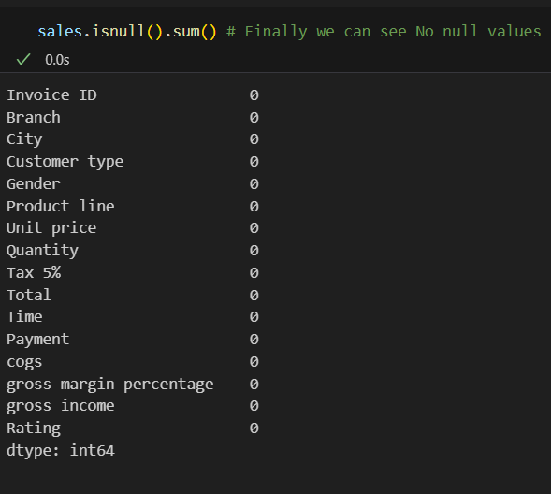

**Fig: 6.1 (Dataset with no null values)**

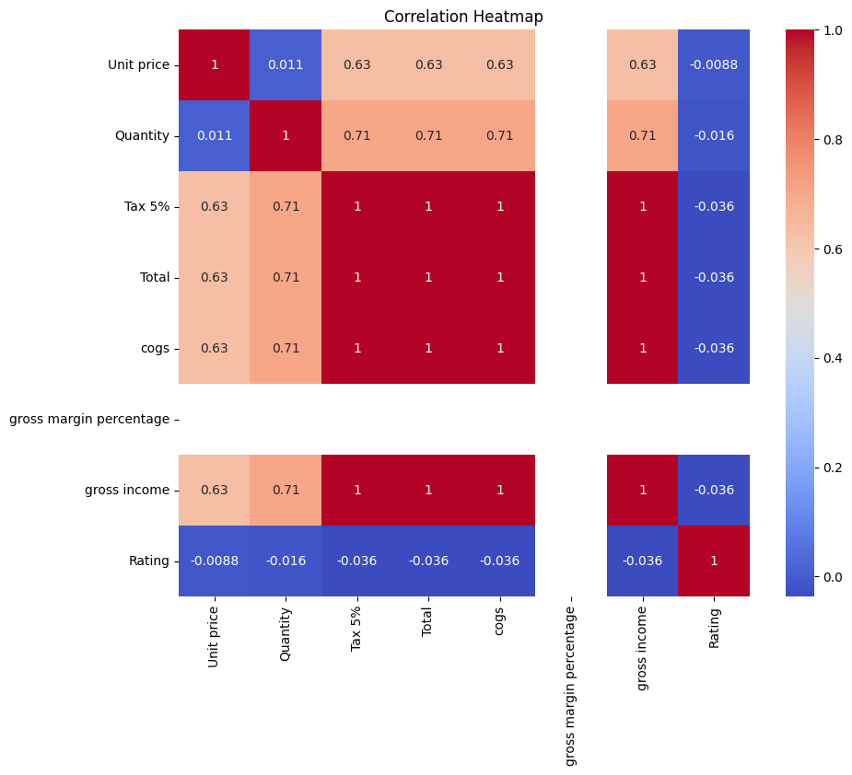

**Fig: 6.2 (Correlation HeatMap of columns)**

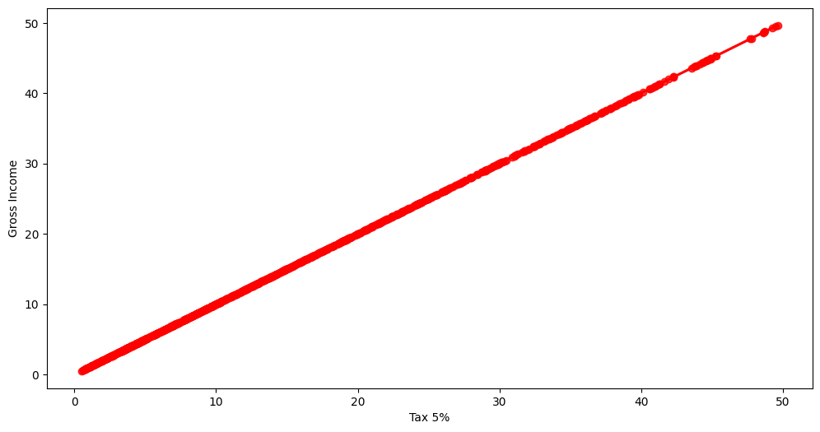

**Fig : 6.3 (Relationship between Gross Income and Tax)**

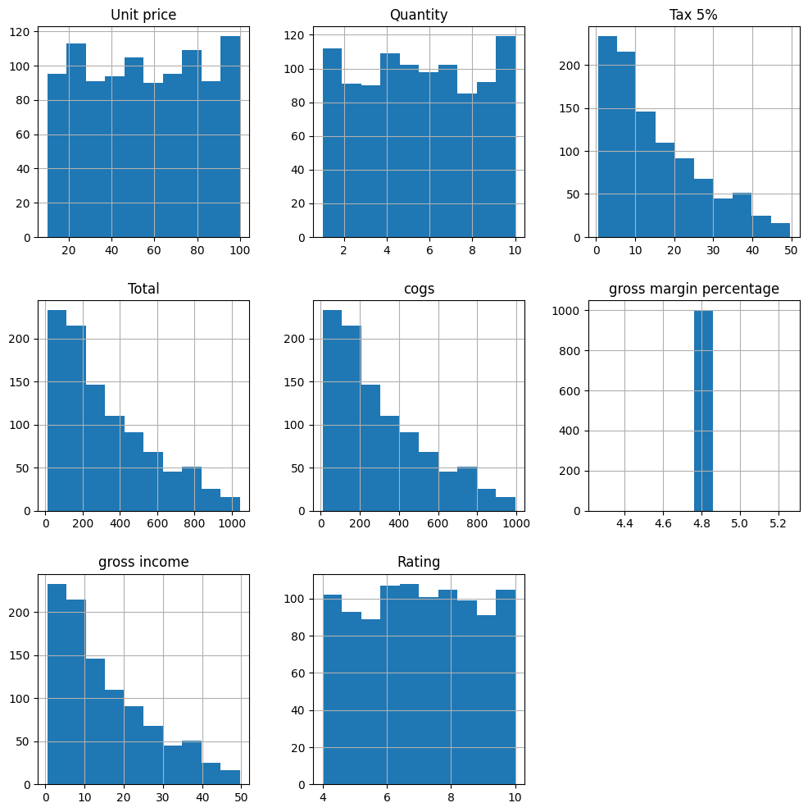

**Fig: 6.4(Histogram showing sales w.r.t columns)**

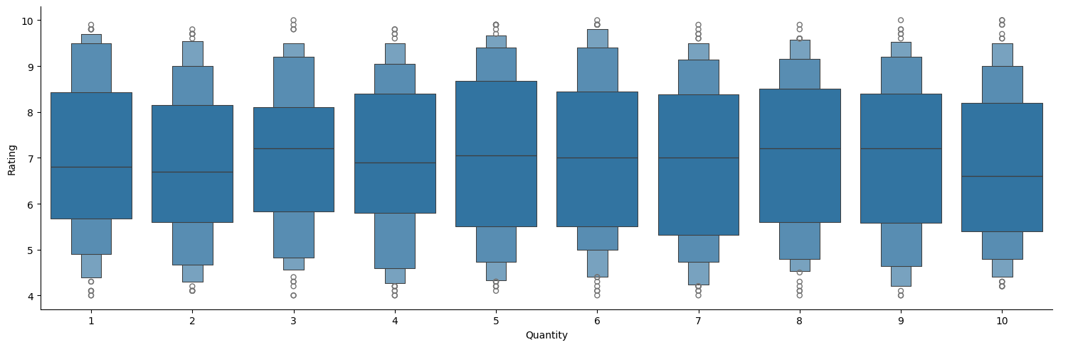

**Fig: 6.5(Box-lot graph between Rating and quantity)**

### ****7. Conclusion****

The **Sales-Analysis** project delivers a powerful and practical solution for supermarkets to better understand their transactional data, which is essential for making informed decisions. By analyzing sales trends, customer behaviour, and inventory patterns, the system helps uncover valuable insights into market demands, popular products, and buying preferences. These insights not only help in predicting future sales but also enable the supermarket to optimize stock levels, pricing strategies, and promotional efforts, thereby enhancing operational efficiency.

The project employs state-of-the-art data analysis tools and techniques, including Python libraries like Pandas, NumPy, Matplotlib, and Seaborn, which provide powerful data manipulation and visualization capabilities. The use of machine learning techniques further enriches the predictive capabilities of the system, allowing for more accurate demand forecasting and inventory management.

With a user-friendly React-based frontend and Flask backend, the system is designed to be accessible to both technical and non-technical users. This ensures that decision-makers in the supermarket can easily access the insights and reports generated by the system, making the tool highly practical for improving business operations.

In conclusion, the **Sales-Analysis** project not only addresses the challenges of understanding and leveraging transactional data but also provides a scalable solution that can grow with the business. By improving revenue generation, reducing operational inefficiencies, and providing actionable insights into customer behaviour, the system contributes significantly to the supermarket's overall profitability and competitiveness in the market. This project lays the foundation for future advancements, such as integrating more advanced predictive models, supporting real-time analytics, and adapting to evolving business needs.

### ****8.Future Scope****

1. **Advanced Analytics**
   1. **Demand Forecasting:** Implement advanced time-series forecasting models (e.g., Prophet, LSTM) to predict sales trends, seasonal demands, and inventory needs, helping businesses optimize stock and reduce wastage.
   2. **Customer Segmentation:** Use clustering algorithms like K-Means or DBSCAN to group customers based on demographics, purchase behavior, and preferences for targeted marketing campaigns.
   3. **Anomaly Detection:** Deploy anomaly detection techniques (Isolation Forest, Autoencoders) to flag unusual sales patterns or fraudulent activities, ensuring data integrity and security.
2. **Real-Time Insights**
   1. **Interactive Dashboards:** Create visually appealing dashboards with tools like Power BI, Tableau, or D3.js, showing key performance indicators (KPIs) in real-time for actionable decision-making.
   2. **AI-Powered Alerts:** Integrate AI to monitor critical metrics and send automatic alerts via email or messaging apps for threshold breaches or emerging trends.
   3. **Predictive Analytics:** Incorporate predictive analytics into dashboards to project future outcomes based on current data, enhancing proactive strategies.
3. **Multichannel Integration**
   1. **Unified Data Aggregation:** Build a central data repository to consolidate data from e-commerce platforms, physical stores, and third-party vendors for seamless analytics.
   2. **Cross-Channel Analysis:** Analyze customer behavior and preferences across channels to identify trends, assess marketing ROI, and uncover new sales opportunities.
   3. **Omnichannel Reporting:** Provide customizable reports showing integrated performance metrics for a 360-degree view of the business.
4. **Customer Feedback Analysis**
   1. **Sentiment Analysis:** Leverage advanced NLP models like BERT or GPT to extract sentiment from customer reviews, tweets, and social media comments for actionable insights.
   2. **Topic Modeling:** Use unsupervised learning (LDA, NMF) to identify common themes in customer feedback and pinpoint areas for improvement.
   3. **Voice of Customer (VoC):** Implement text-to-speech and speech-to-text tools to analyze spoken feedback, further broadening insights from customer interactions.
5. **Global Scalability**
   1. **Localized Analytics:** Tailor analytics to regional preferences by incorporating local currencies, languages, and cultural nuances into dashboards and reports.
   2. **Multilingual NLP:** Use language models to process text data in multiple languages for global customer sentiment analysis.
   3. **Region-Specific Insights:** Provide region-specific analytics for localized marketing strategies and demand forecasting.

### ****9. References****

### Youtube link for seaborn –

### <https://www.youtube.com/watch?v=DWVLRhnuGqI&t>=369s

### Chatgpt- www.chatgpt.com

### W3schools link used for understanding library-

### <https://www.w3schools.com/python/matplotlib_intro.asp>